CERTIFICATE OF Master DEGREE

This is to certify that Mr. , born on , native of province, having satisfactorily completed the prescribed graduate program and passed the thesis defense, according to “THE RULES FOR ACADEMIC DEGREE OF THE PEOPLE’S REPUBLIC OF CHINA,” is hereby awarded this certificate of the Master’s Degree of .

Yang Wei

President of Zhejiang University
Yang Wei
Chairman of Degree Evaluation Committee

From Sept.15th, 1998, Zhejiang University, Hangzhou University, Zhejiang Agriculture University and Zhejiang Medical University merge into Zhejiang University.

Issued on
Certificate No.:

注意事项
1、请根据实际情况填写，需要学位证书的原件及复印件一份。
2、2005年12月后取得学位英文副本的研究生不需做此项翻译，把英文副本的原件及复印件带过来即可。
3 、Issued on一栏填写学位授予日期；Certificate No.一栏填写证书号码。
4、下面有研究生院制作好之后的样本。

下图是研究生院制作好之后的样本（复印到防伪纸上）

无英文副本
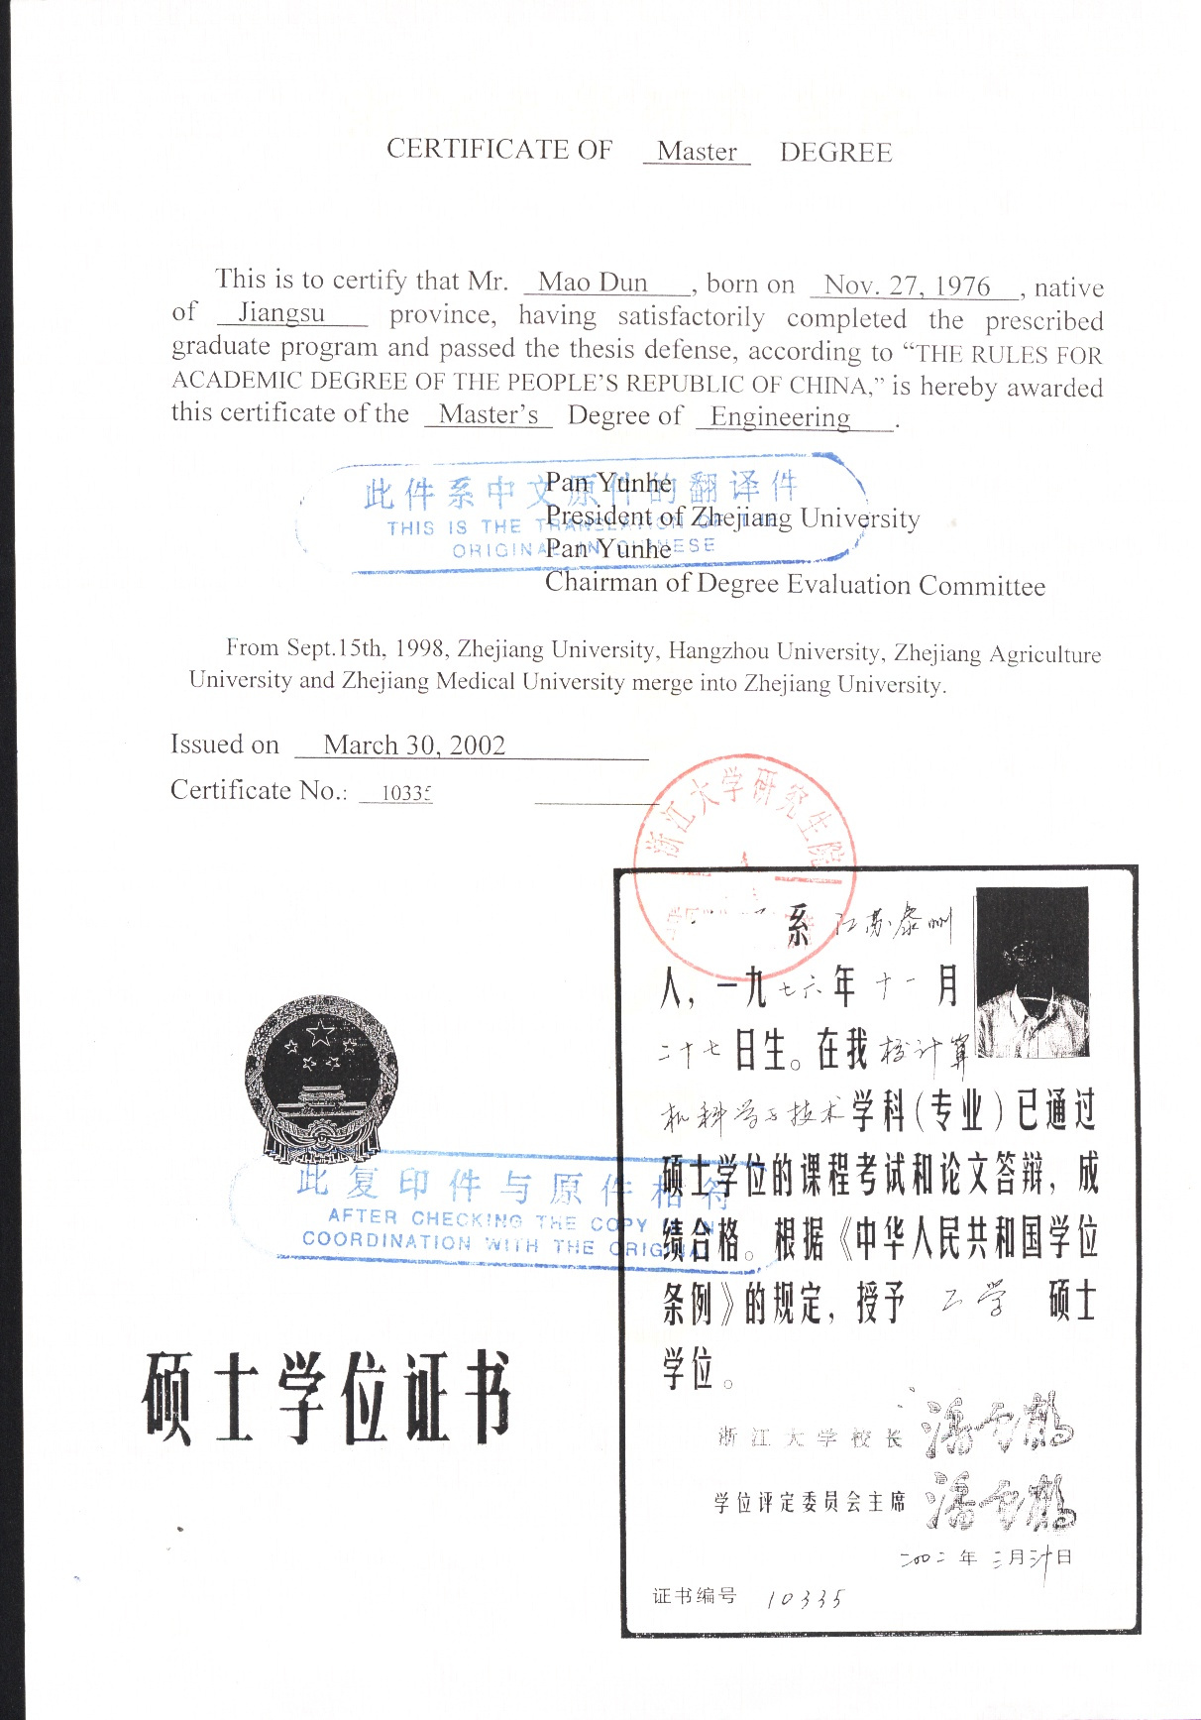

有英文副本

